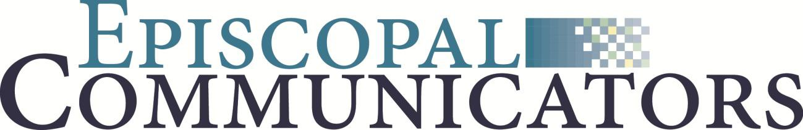

Annual Business Meeting Minutes
Via Zoom
August 6, 2020

Opening prayer: Jason Merritt
President Jason Merritt called the business meeting to order at 2:03 EDT pm and confirmed that there was a quorum (10% of members required in attendance).

The minutes of the 2019 annual meeting held at the Curtis Hotel in Denver Colorado, were approved as presented.

Financial: Bill Slocumb

Bill Slocumb reviewed the year-end 2019 financials.

Highlights:
- There were twelve sponsors for the EpisComm19 for a total of 22,500.
- Administrator staff time was increased to half time.
- EpisComm19 broke even with sponsorships. We incurred additional expenses because of key note speaker.
- Bill reviewed income and expenses for 2019.
- Bill reviewed 2020 financials through the second quarter.
- The board will not have an on-site fall board meeting.
- Looking to break even and possibly add to reserves for future events.

Operations:
- Moved payment processed from PayPal to a Wild Apricot service.
- Bill thanked those who donating in 2019 for giving Tuesday and those who donated their onsite conference fee.
- The board will be discussing how to best use any surplus reserves.

President report – Jason Merritt

- Jason noted how crucial the role of communicators is to the mission and ministry of the Episcopal Church.
- The board is being realistic about the possibility of not having an in person 2021 conference. The board will discuss further and let the membership know as soon as possible
- There are currently 336 active members.
- Twenty who have joined in the past month.
- Moving forward the board will focus on the Facebook group.

- Jason thanked committee members.
  - Professional Standards - Sarah Bartenstein, chair, Ashley Graham-Wilcox, and Mike Orr.
  - Professional Development - Christine McTaggart, chair, and Nicole Baxley
  - Membership - Nicole Krug, chair, Natalee Hill
  - Polly Bond Committee – Denise Fillion, Paulette Martin, Ellen Singer
- Jason also thanked the following:
  - Those who submitted their work for Polly Bond consideration, workshop presenters and keynote speakers.
  - Current board and new board members.
  - Administrator, Lori Daniels
  - Treasurer, Bill Slocumb
  - Board member Heidi Pitts, Karen Mackay, and Melodie Woerman who have rotated off the board.

Jason noted that videos of the workshops will be available as soon as possible for conference attendees, and will have them up for all members afterward.

Meeting adjourned by Jason Merritt at 2:22 pm EDT

Respectfully Submitted,
Lori Daniels

